**User Guide**

**Employee Logins**

|  |  |  |  |
| --- | --- | --- | --- |
| **Name** | **Job Title** | **Staff ID** | **Password** |
| Bruce Lee | Big Boss | 1 | Pass123 |
| Patrick Brady | Warehouse Manager | 8 | Pass123 |
| Teagan McDonald | Supervisor | 9 | Pass123 |
| Robyn Murray | Warehouse Picker | 10 | Pass123 |
| Freya Clayton | Mailroom | 11 | Pass123 |

**Customer Logins**

|  |  |  |
| --- | --- | --- |
| **Name** | **User ID** | **Password** |
| Test User | Testuser | Password |
| Aaron McEwen | Aaron1 | P1zz4 |
| Sophia Peacock | SophPea | Ilovedogs |
| Gabriel Blake | Gabe43 | Iangabe |
| Matilda Bray | Matilda98 | 12345 |
| Dylan Gilbert | DyGilz | Pizzarules |
| Josh Peters | JayP33 | Wales |
| Michael Cooper | Cooper | p123 |
| Ella Brady | EllaElla | 123456 |
| Brandon Oliver | Brando666 | Devil |
| Aidan Perry | Aiiidaaan4 | Poptart |
| Samantha Savage | SavageSam | S4v4g3 |
| Andrew Coles | Colesalw1969 | naylor |

**Public Access**

<https://zeno.computing.dundee.ac.uk/2017-ac32006/team20/index.php> takes you to the homepage of our webpage.

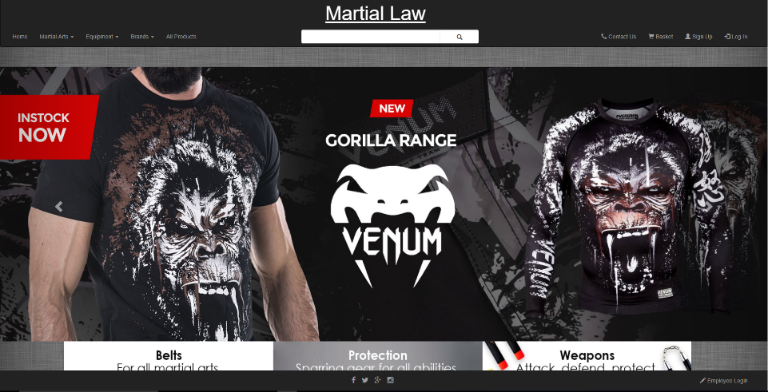

From there you can browse the products we offer by using the left hand side of the toolbar. You can either view all products or a subset of them by selecting what you are looking for using the dropdown menus or using the searchbar.

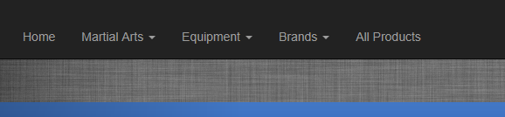

Clicking on one of these links will take you to the product view page, displaying the available products that are in stock. The number of hits of the database is also shown.

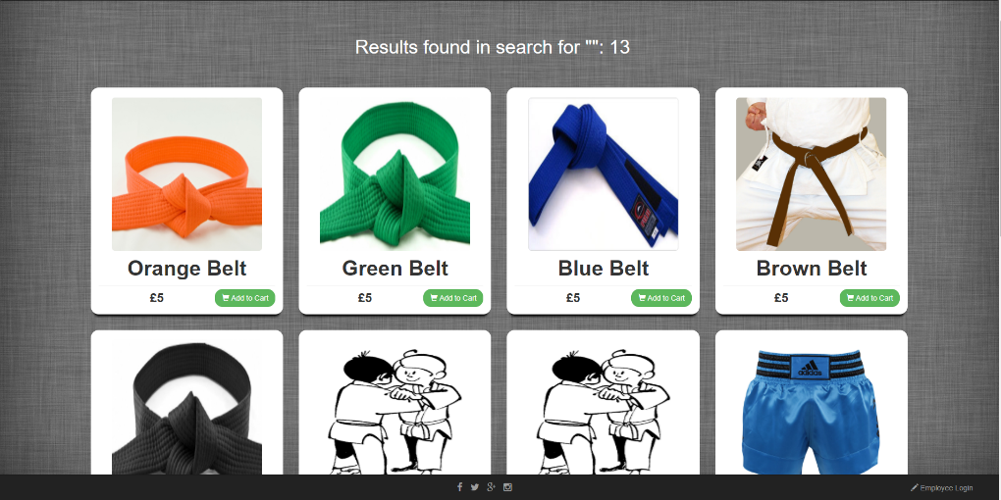

Clicking on one of the products results in a brand new window being displayed on top. It contains a lot more detail.

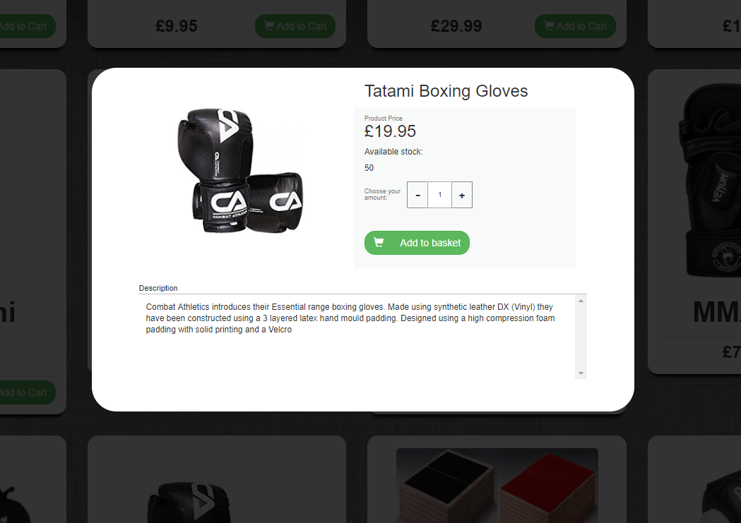

The contact us link takes you to the contact page, where the user can find various contact information as well as a google map image showing the location of our office.

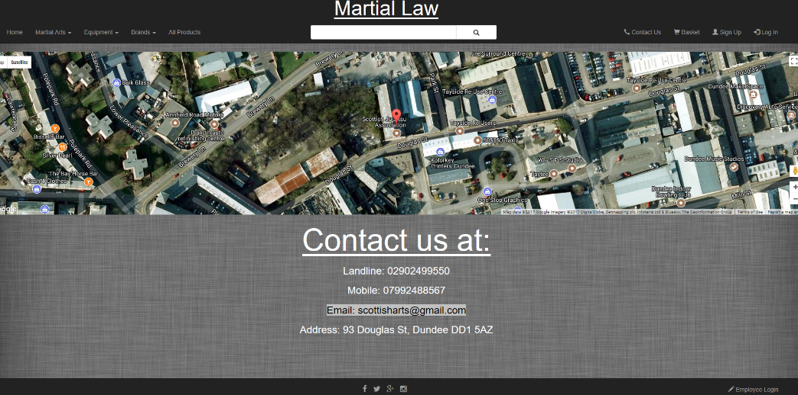

**Customer Access**

For the full customer experience you will have to sign in. You do so by selecting the log in option on the right hand side of the tool bar.

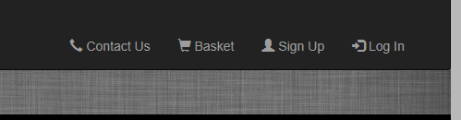

This link will take you to the sign in page for customers. Here you will enter a user ID and password to access your personal page.

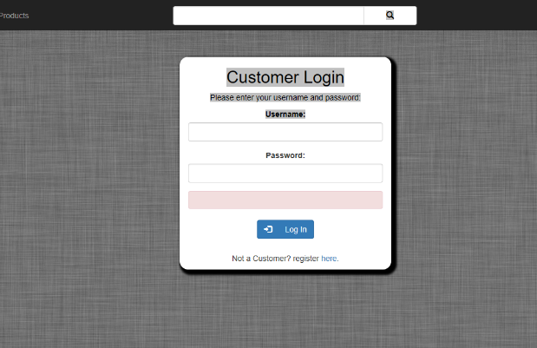

If you haven’t registered and do not have a user ID and a password then either select the sign up tab on the right of the tool bar or the link at the bottom of the log in form.



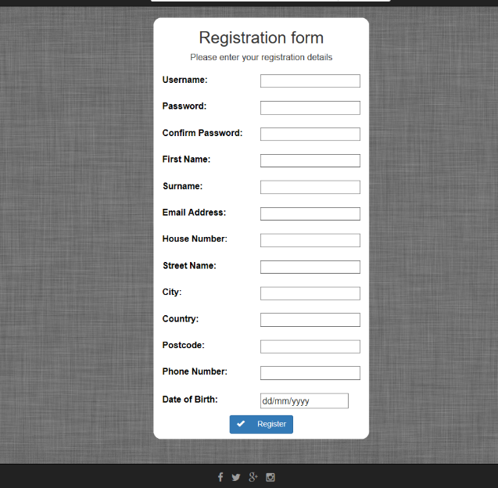This will take you to the registration page where you are required to enter some personal information to create an account. Put sensible information inside the fields as any unexpected input will be rejected.

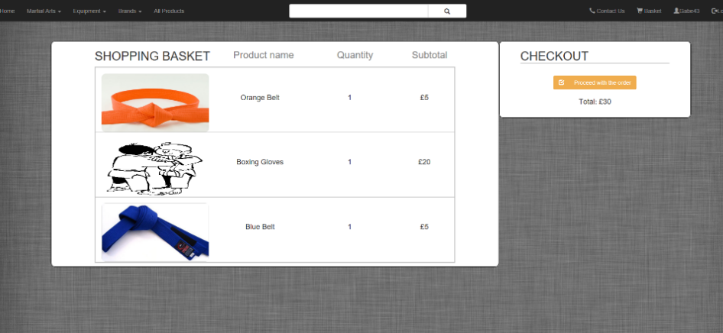Once you are logged in you gain access to the shopping feature. You can add the products to the basket using the button on product view. Items in the basket can be seen by clicking on the shopping cart icon on the toolbar. During check out you can see detailed information about the contents of your cart;

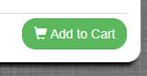

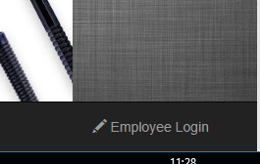**Employee Access**

To login as a staff member you will have to use the employee login link at the bottom right of the page.

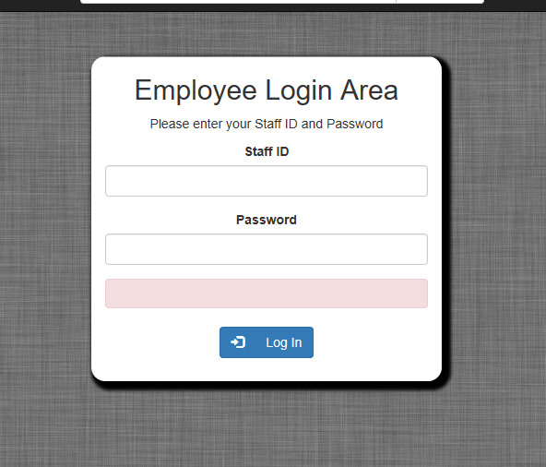It will take you to the employee login page where you will have to enter staff ID and password to gain access. If you have previously logged in as staff it will just redirect you to the dashboard.

Once logged in, you gain access to the employee dashboard where you view your details, add products, view previous orders, add a new employees, view all employee information and delete employees or customers.

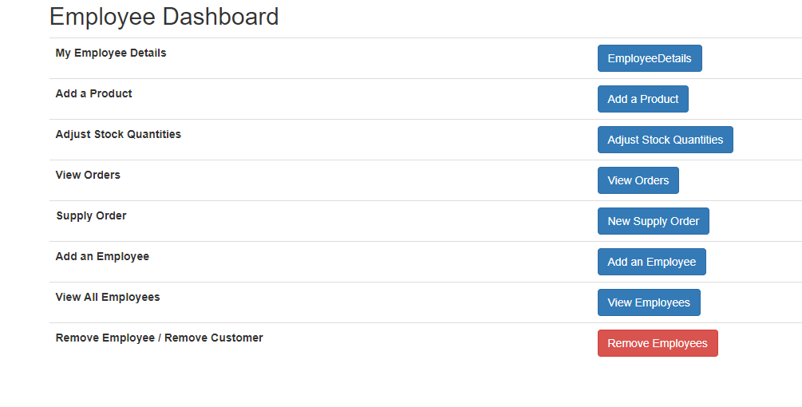

**Add a Product** takes you to the product registration page where you will have to enter various details about the product before adding it to the database.

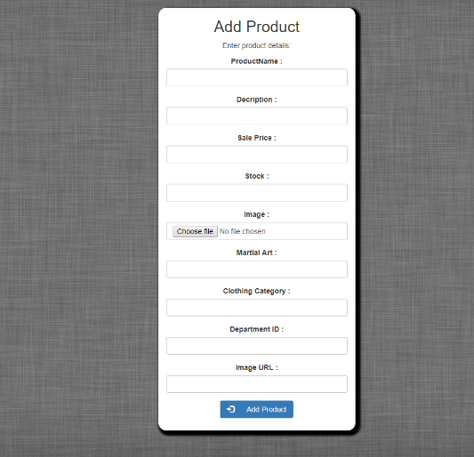

The **add an employee** button takes you to the employee registration form where personal data about a new emplyee will have to be entered before being enter to the staff table.

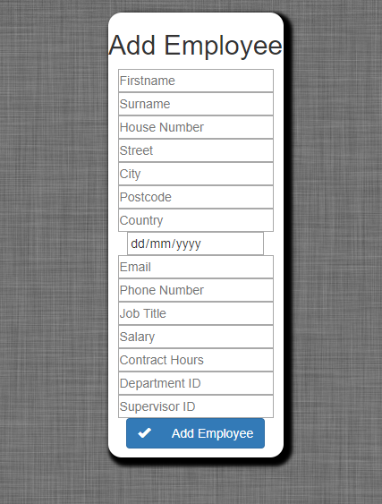

The employee details button takes you to a form that displays the information stored about you.

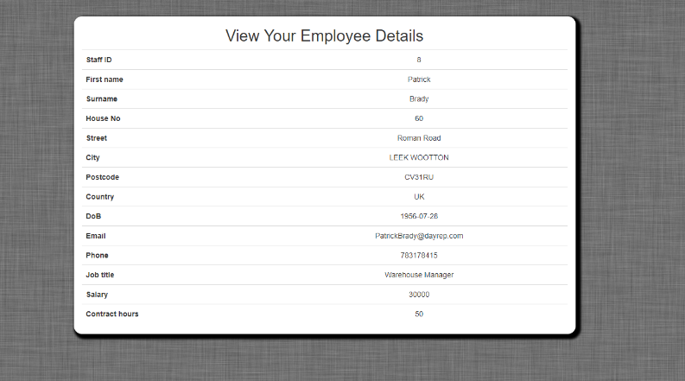

**Delete employee** **/ customer** takes you to the delete page where you get a choice to delete a employee by ID or a customer by username.

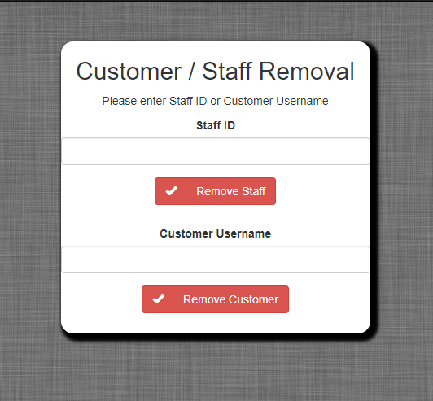

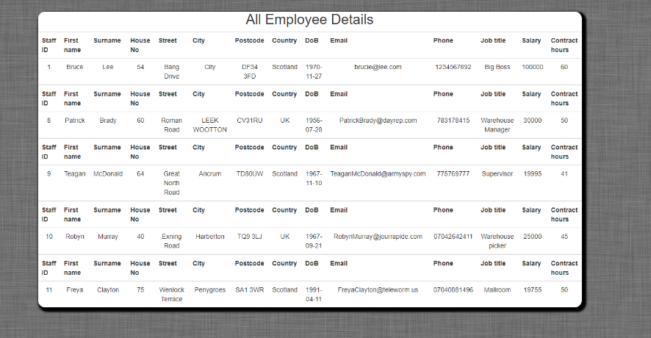**“All employees**” shows you all of the existing employees registered in the database.

At the far right end of the tool bar logout function can be found if you want to end your session.

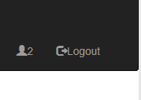

**Database Views**

There are four created views in the database.

The first is **CustomerView**, which was designed to return a result set from the Customer table which contains most but not all of the fields stored in the database for customer. These fields were selected as the most relevant information that a customer may want to review when logging into the application such as their first name, surname, address details, email, and so on. Other fields such as the user’s password (vPassword), and unique database user ID (CustomerID) were deliberately not included in this view so that they remain protected in the database, and do not reveal to the user how the database is structured.

**CREATE VIEW** *CustomerView* **AS SELECT** *vUsername, Firstname, Surname, HouseNo, Street, City, Postcode, Country, DoB, PreviousOrders, Phonenumber, Email* **FROM** *customer;*

The second is **EmployeeDetails**, which was designed to provide details to the employees of the company. Like the previous example, this view returns common details from the Staff table intended for review and possible updating such as their address details and StaffIDs which they use for log in. Higher level management data such as DepartmentID, SupervisorID are not returned in this result set.

**CREATE VIEW** *EmployeeDetails* **AS SELECT** *StaffID, Firstname, Surname, DateOfBirth, Email, PhoneNumber, JobTitle, Salary, ContractHours, HouseNo, Street, City, Postcode, Country* **FROM** *Staff;*

The third and fourth views, **ProductListView** and **ProductDetailView**, are intended to display different levels of information to customers on the public facing website. ProductListView was originally designed to be a lighter weight view of the products table fetching less fields per record. This is because it is responsible for displaying a large list of Products from the database and less fields could potentially help speed up the databse fetch when the Product table contains a lot of items. ProductDetailView was designed to then provide more in depth information about specific products after the user clicks a link. The views also aim not to display products which are out of stock by specifying that the Stock field should be greater than 0.

**CREATE VIEW** *ProductListView* **AS SELECT** *ProductID, ProductName, SalePrice, ImageURL, MartialArt, ClothingCategory* **FROM** *product* **WHERE** *Stock > 0;*

**CREATE VIEW** *ProductDetailView* **AS SELECT** *ProductID, ProductName, Description, SalePrice, Stock, ImageURL* **FROM** *product;*

**PHP QUERY**

A query in **“ProductPage.php”** used to search for items with partially matching fields.

$initialquery = "SELECT * FROM ProductListView WHERE ProductName LIKE '%".$sbar."%' OR MartialArt LIKE '%".$sbar."%' OR ClothingCategory LIKE '%".$sbar."%';";

$shortproducts = $mypdo->prepare($initialquery);

$shortproducts->execute();

while($presult = $shortproducts->fetch()){

…

In order to retrieve relevant information from the database we must compare database entries with our initial string $sbar. If only one field was used to compare, the results would be not entirely accurate. As a result of that the query looks for any row that has partially matching fields. We look into “ProductName”, “MartialArt” and “ClothingCategory”. It is interesting how long a query becomes just from a few extra parameters.